**RPost- Outlook Service**

**Version: 1.1**

**Created By: Sheeraz Shaik**

**Review By: Hemanth Ala**

**Last Revised on: 03/16/2015**

**Department: RPost IT**



Table of Contents

1 Overview 4

2 Configuring R-Mail desktop to Outlook: 4

3 Outlook Service Overview: 5

3.1 Compose Email: 5

3.2 Send Dialogue Panel (Options in Send Registered Button): 6

3.2.1 Track & prove Options: 7

3.2.2 Standard – send with official banner markings: 7

3.2.3 Flow chart for Standard Message: 8

3.2.4 Use cases for Standard: 8

3.2.5 Unmarked – send message without banner 10

3.2.6 Flow chart for Un-marked Message: 11

3.2.7 Use cases for Un-Marked: 11

3.2.8 E-Contract – Request recipient signature to record agreement 11

3.2.9 Hand Sign: 13

3.2.10 Flow chart for Hand Sign Message: 16

3.2.11 Flow chart for Encrypted Hand Sign Message: 17

3.2.12 Email Sign 18

3.2.13 Flow chart for Email Sign: 21

3.2.14 Sequential Signing: (From Gmail App) 21

3.2.15 Flow chart for Sequential Hand Sign Message: (2 recipients) 22

3.2.16 E-Contract 🡪Options tab 🡪 23

3.2.17 Control panel Settings: 25

3.2.18 Use cases for E-Contract (Hand Sign and Email Sign) features: 28

3.2.19 Encrypt – send end-to-end encrypted for extra privacy 31

3.2.20 Options tab 🡪 Encryption: 33

3.2.21 Control Panel Settings: 36

3.2.22 Use cases for Encryption: 38

3.2.23 Large-Mail – Large file transfer service 38

3.2.24 Options Tab 🡪 Large-Mail 38

3.2.25 Control panel Settings: 40

3.2.26 Use cases for Large-Mail: 40

3.2.27 Side Note 41

3.2.28 Options Tab 🡪 Side Note 41

3.2.29 Use cases for Side Note 42

3.2.30 More>> Options: 42

3.2.31 Attachments 42

3.2.32 Options Tab 🡪 Attachments 44

3.2.33 Use Cases for Attachments 44

3.2.34 Register Reply 44

3.2.35 Options Tab 🡪 Register Reply 45

3.2.36 Use Cases for Register Reply 46

3.2.37 Client/Reference Code 46

3.2.38 Options Tab 🡪 Receipt Management 46

3.2.39 Control panel Settings: 47

3.2.40 Use cases for Client/reference Code 48

3.2.41 Sender Signature & Authentication 48

3.2.42 Options tab 🡪 Signature pad 48

3.2.43 RPost link: Sign email and PDF attachments 48

3.2.44 Options Tab 🡪 General 48

3.2.45 Options Tab 🡪 Languages 50

3.2.46 Options Tab 🡪 RPost Account 50

3.2.47 Options Tab 🡪 Specialized Configurations 50

3.2.48 Apps tab 50

3.2.49 RPost Version number and Help button 50

4 Acknowledgement Email 50

4.1.1 Use cases for Acknowledgement Email: 52

5 Registered Receipt 52

6 Open Receipt 54

7 Receipt Authentication 55

8 Final E-Sign off Document 56

9 X-Headers List 57

10 Subject Line Commands 60

11 Control History 61

# Overview

This document outlines the steps to install/configure the R-Mail desktop to Outlook and multiple features available to send an email using RPost services.

# Configuring R-Mail desktop to Outlook:

Installing and configuring the R-Mail Desktop software adds a "Send Registered™" button to the mail compose window in Microsoft Outlook. The button will appear above or next to the traditional "Send" button, and allows the user to send Registered Email® messages. R-Mail Desktop software includes the following services; Registered Email messages, encryption, electronic signature & contracting, PDF conversion, authentication, metadata cleaning, and more...

* **R-Mail Desktop for Outlook can be downloaded as per the below steps:**
* Navigate to www.rpost.com
* Select Apps & Downloads tab from header panel
* Select All Apps link
* Select the appropriate icon, based on the bit number of your version on Outlook.
* **New /First time Installation:**
* The RPost plug-in for Microsoft Outlook requires the prerequisite of Microsoft .NET Framework 4.0. If you are unsure which version of .NET is installed on your computer you may continue to Step 2 and install the button. You may be prompted to install .NET4.0 if required.
* Confirm the bit number of your version of Outlook 2013

Open Outlook and press: File > Help

* Confirm bit number of Microsoft Outlook (32-bit or 64-bit)

64-bit

**Note:** Microsoft Windows and office are broken down into 32 and 64-bit.The RPost outlook App works for all versions of Windows and Office however the software must correspond to the bit version of office rather than Windows.

For example, a computer with 64-bit Windows with Office 32-bit would require the 32-bit version of the RPost Add-in.

* Close Microsoft Outlook, Microsoft Word and other programs tied into Outlook.
* Click the Download button above and follow the screens depicted below.

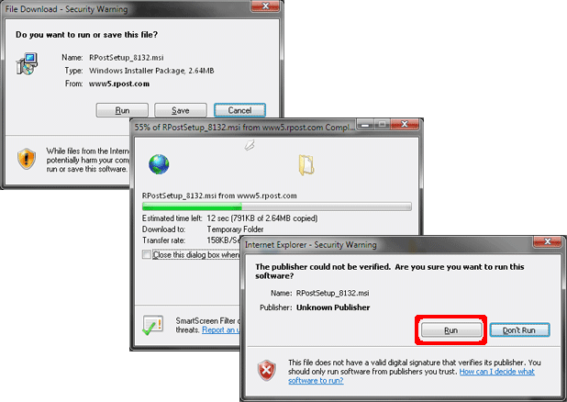

# Outlook Service Overview:

* Compose Email
* Send Dialogue Panel
* Sent item
* Registered Email message (Standard)
* Acknowledgement Email
* Registered Receipt Email
* Receipt Authentication Email (Disputes only)

## Compose Email:

* Compose an email like any other message
* Attach files of any type to the email
* Press the ‘Send Registered” button

**Note:**

* RPost emails may have up to 10 recipients per message on Trial basis and up to 100 recipients per message for a registered user.
* Duplicate recipient address will be discarded, and only the unique address will be considered for calculation of units.
* RPost emails may have up to 20 MB in size or up to 200 MB with the Large-Mail service in use

**Message or Unit:**

* A message or Unit is defined as a single recipient address per 5MB in size. This means that an email sent to two people with an attachment of 6MB will be considered as four units.

Refer the screen shot below for the Registered Button, in Compose Email layout:

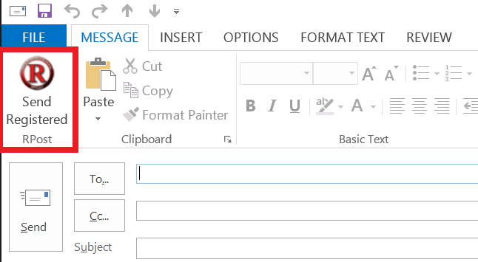

## Send Dialogue Panel (Options in Send Registered Button):

* The feature dialogue appears after the “Send Registered” button is clicked from email compose page.
* Choose any of the options to register, encrypt, send for electronic signature or send a large file.
* Click the “options” button on the bottom of the pop-up to configure the service to your needs

Please refer the screen shot below for the Send Dialogue panel options:

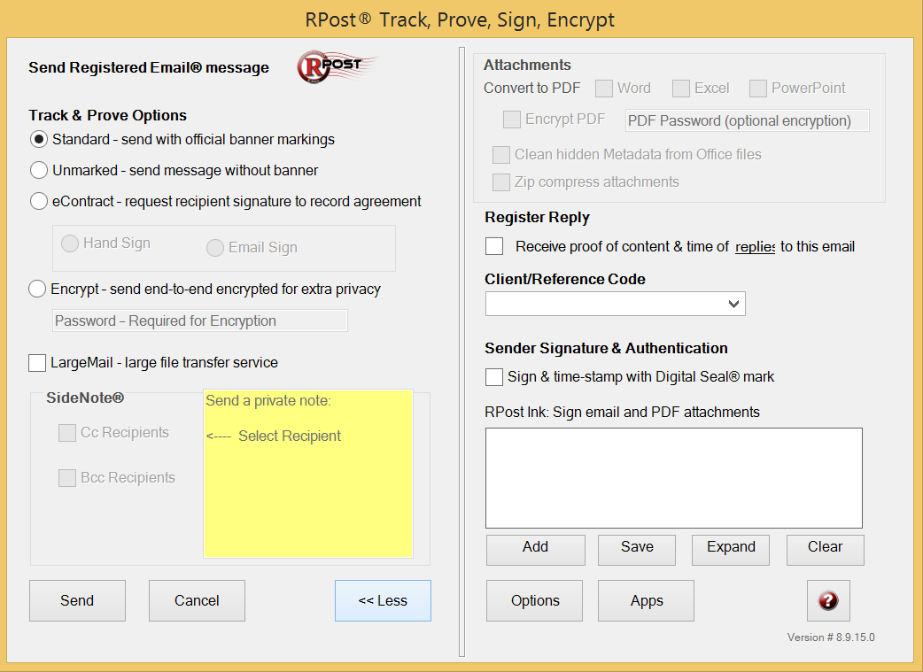

### Track & prove Options:

### Standard – send with official banner markings:

* When Standard option is selected, Email will be marked as Registered in the subject line
* Registered Email banner is included in the body of the email.
* No recipient action is required here.
* By default, Standard option is selected in Track & prove options.

**Refer the screen shots below for the Standard/Marked emails:**

**Subject line:**

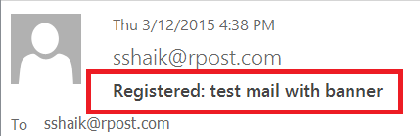

**Email Body: Registered Email banner**

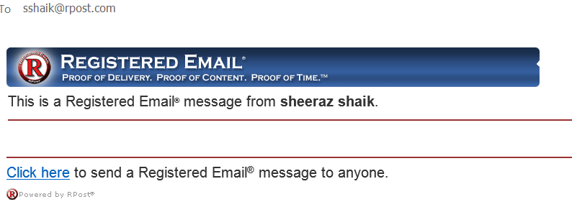

### Flow chart for Standard Message:



### Use cases for Standard:

1. Marked message is sent to multiple recipients included in To , CC and BCC fields

**Expected Result:**

All the recipients should receive the marked message irrespective of whether in To, Cc or Bcc fields

1. Is there any option to send an email without Registered banner

**Expected Result:**

Yes, an email can be sent without a Registered banner, just by selecting the Un-marked option.

1. Send a standard Encrypted email, Will there be any change in Banner?

**Expected Result:**

Yes, ‘Registered Email’ banner gets replaced with ‘Encrypted Email’ banner

Refer the screen shot below for the Encrypted Email banner:

Email Body: Banner with Encrypted Email

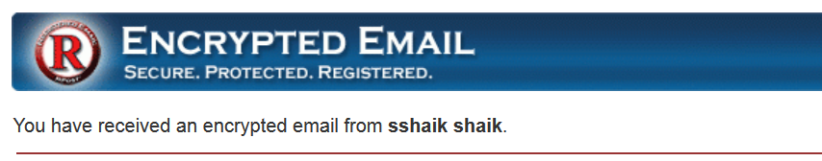

1. Send an Encrypted email with TLS, Will there be any change in Banner?

Expected Result:

‘Registered Email’ banner gets replaced with new banner, which includes both ‘Registered Email’ and ‘Transmitted Encrypted’ in banner

Refer the screen shot below for the Transmitted Encrypted Email banner:

**Email Body: Banner with TLS**

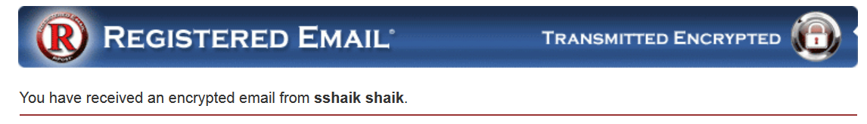

1. Send a standard hand Sign email, Will there be any change in banner?

Expected Result:

For Hand Sign, there will not be any specific banner, but the header in the email says “RPost- Electronic Signature request”

Refer the screen shot below for the Standard Hand Sign:



1. Send an encrypted hand sign email, will there be any change in banner?

Expected Result:

For Encrypted Hand Sign, there will not be any specific banner, but the header in the email says “RPost- Electronic Signature request – Transmitted Securely”

Refer the screen shot below for the Encrypted Hand Sign:



### Unmarked – send message without banner

* When unmarked option is selected, the email will not be marked or identified as Registered in the subject line
* Registered banner is NOT included in the Email body and the recipient just sees it as an ordinary email.
* No recipient action is required here
* To keep it simple , Sending “Unmarked’ Registered Email messages remove all RPost markings

**Note:** Even though the mail is not marked as Registered, still the sender will receive the registered receipt proof as email is delivered.

**Refer the screen shot below for the Unmarked Email:**

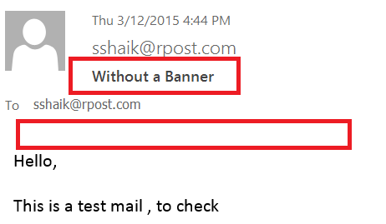

### Flow chart for Un-marked Message:



### Use cases for Un-Marked:

1. Can an E-Contract be sent as Un-marked message?

**Expected Result:**

No, E-Contract cannot be sent as an Un-marked message. The E-Contract option gets disabled, as and when user selects Un-marked option.

1. Can an Encrypted email be sent as un-marked message?

**Expected Result:**

There is no significant impact of Un-marked option on encrypted emails.

### E-Contract – Request recipient signature to record agreement

* E-Contract option requires recipient action
* This option enables the sender to have agreements signed instantly with electronic signatures right onto agreements. It’s way simple for the sender ,just compose email ,attach agreement and send to recipients
* The recipient can sign the attached documents electronically and send it back to sender instantly by avoiding the delays of printing, signing and faxing agreements back and forth. The recipient is not required to download software or subscribe to any service.
* E-Contract service is simple to use with minimal training, fast and uncomplicated integration into any platform or sending from any mail program.
* The agreement can be in email body or attached to message for flexibility
* The agreement can be sent to single or multiple parties for signature
* E-Contract service does not require any initial document setup or uploading documents to a 3rd party website.
* Document is cryptographically PKI digitally signed
* Allowed document types are Word, Excel, PowerPoint and PDF ( on .org system)
* All the Office files are converted to PDF automatically to maintain the integrity and to enable the signing process for recipients.

**E-Contract/E-Signature Service:**

* Compose Email
* Attach the required documents to mail
* Open Send dialogue panel
* Select E-Contract option
* Select either Hand Sign or Email Sign option
* Send the Email/Message
* Sender receives an Acknowledgement email , that message has been sent
* Recipient receives the agreement attached to Registered email
* Recipient selects ‘Click Here” link to review and sign the document
* All the Recipients and sender receives an ESign-off document with all recipient signatures in the agreement ( only after all the recipients agrees to the agreement)
* Registered Receipt will be sent to sender as a proof of delivery.

**Note:** For more details on Registered Receipt, refer the registered receipt section

* Second Receipt will be sent to sender , for the signed contract

**RPost E-Signature/E-contract options in features available in Microsoft Outlook:**

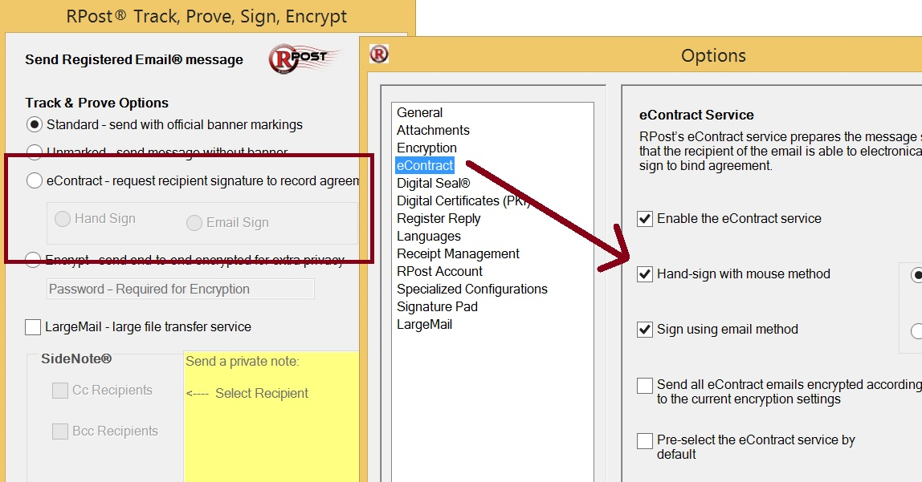

### Hand Sign:

* Hand sign option can be selected in Send Dialogue panel 🡪 Hand Sign
* The sender requests the recipient to review the attached documents and confirm it with a Hand sign.
* The is no option provided for recipient to modify the document, thus maintaining the integrity of the document
* E-sign off document gets generated automatically and sent to all recipients and sender ( only after all the recipients accepts the agreement)
* Signatures of all parties are included in last sheet of E-sign off document as ‘Signature Certificate’ ( only after all the parties accepts the agreement)
* All the recipients in TO field are allowed to sign the document. Cc and Bcc recipients should not be allowed or given an option to sign the agreement.

**Note:** More details on E-Sign off final document, refer to ESign-off section.

* Sender receives a notification email, as and when each of the recipient signs the document, along with an option to retrieve the ‘partially signed contract’.

**Refer the screen shot below, for the notification email:**

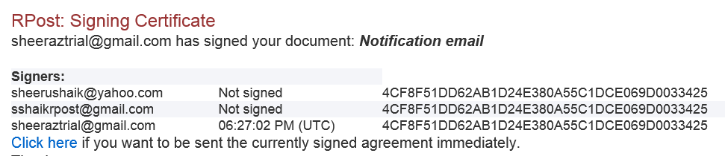

* Partially Signed contract gives the flexibility to the sender to retrieve the contract , when ever needed ( no need to wait till all the recipients sign the contract)

This is similar to final e-sign off contract document, but the signature document consists of only the signatures of the signed recipients.

* Encrypted Hand Sign – An encrypted hand sign works same as encrypted message , where the hand sign email will be in encrypted form ( either system generated or user generated password) , with the banner as “RPost- Electronic Signature request – Transmitted Securely”
* All the encryption settings or rules set in control panel /options, will be applicable to Encrypted hand sign as well.

**E-Sign Page:**

* E-Sign Page – Once the recipient clicks on “Click here to Sign “link from the hand sign message, e-sign off service starts, in a new window.
* Click to Sign and Click to Type instructions will appear based on the Annotation setting in control panel ( Refer Control panel 🡪 Annotation settings below)
* Click to Type - Recipient can type in any required text by using ‘Click to Type’ button and can position the text anywhere on the document
* Click to Type – There is no limit on number of characters
* Click to Sign – Recipient can sign on the document by using Click to Sign button and can place it anywhere on the document
* Click to Sign – Limit is 30 characters
* Clear Document – This option clears all the information entered on the document, on all pages, including the information entered using the mouse, clears all the information entered by using Click to Type, Click to Sign and by using mouse
* Confirmation pop up should appear to confirm the user action after recipient clicks on ‘Clear Document’ button. The pop up should read as “ This will clear all the information entered by you from all pages of the contract” ( This pop up is not yet implemented)
* View PDF – This option enables the recipient to download and view the pdf document, sent for e sign process
* Undo last Line – This option gets enabled, when recipient enters some text by using mouse. And also clears the last line drawn by the recipient.
* Recipient can navigate to any page on the document by clicking on either the page numbers at the top of the document or by clicking on right and left arrow buttons.
* Session Timeout – Session time limit for an econtract is 20 minutes. Session gets expired after 20 minutes. Recipient has to click on Click here link from original message to initiate the signing process again. All the data entered by the recipient will be lost, if session gets expired.
* I icon – I icon is the information icon , which gives the basic details or steps of the e sign process
* Decline Button - Recipient can click on ‘Decline button’ to decline the contract by giving appropriate comments
* Finish Button – Recipient can progress to final step of singing contract by clicking on Finish button
* Recipient can enter the name in the “Please enter your name “ field and this gets displayed in the Auto Signature field , and also gets displayed in the Signature field in the final econtract , if there is no signature ( From Draw it) associated with the document.
* If there is both name and signature entered by recipient, then in final e contract, name gets displayed in Name position and Signature gets displayed at the Signature position.
* Name Field , Character Limit is 80 characters
* Title is optional here and is applicable only if the contract is associated with Word tags.
* Recipient can draw the signature by Mouse by using Draw it button.
* Once the Recipient clicks on Draw it button, Clear option should be enabled to clear off the signature (otherwise clear option should not be visible)
* Tags – When the document sent for e-signoff is associated with tags like <<name>>, <<Title>> etc. then these tags should get automatically replaced with all the information entered by recipient in the final step of the e-signoff page. The recipient should not see these word tags when opened the document for signing.
* Tags - When the document with tags is sent to multiple recipients , then none of the recipients should see the tags in the document
* Tags – If the sender retrieves the partially signed contract , even then tags should not be visible in the partially signed contract, as sender might need to print the document ( Not yet implemented )
* **Document Types :**

Org System - Allowed document types are Word, Excel, PowerPoint and PDF

BIZ System - What we should have - Word (doc/x) Excel (xls/x) PowerPoint (ppt/x/PPS), TXT, JPEG, TIFF, GIF, PNG, BMP, PUB, WPD (Word Perfect), Microsoft Access, RTF, HTML, EML, CSV ( Not yet implemented )

* All the special characters , numbers, upper case , lower case letters are allowed in document names , sent for hand sign process
* All the special characters , numbers , upper case , lower case letters are allowed in the subject line of the hand sign process
* Hand Sign with Register Reply – When hand sign with register reply is sent to recipient and any reply from recipient should come as registered message. The units for register reply will get deducted from sender’s usage limit.
* A hand sign message can be forwarded to a different recipient by the original recipient and they can sign /agree the contract on behalf of original recipient.

The final e contract document still shows the original recipient address in the original recipient field

* A hand sign can be either signed or declined only once , either by original recipient or a different recipient ( if forwarded by the original recipient )
* A reply to the hand sign message should not be considered as singed agreement.
* Document Lock – There will be a lock on the e sign off page, when any one of the recipient is in signing process. All the other recipients receives the document lock error page. Default time for document lock is **3 minutes**.
* Hand Sign expiry – Default expiry date for all hand Sign documents is **30 days**, if any recipient tries to access the link after 30 days should receive an error page.
* There will be an information message in the hand sign email as expiry date for the

hand sign messages is 30 days ( Not implemented yet)

### Flow chart for Hand Sign Message:



### Flow chart for Encrypted Hand Sign Message:



**Encrypted hand Sign with User – Generated password:**



### Email Sign

* Email Sign option can be selected from Send Dialogue panel 🡪Email Sign
* E-Sign off by Email service obtains the fastest electronic signature with only a few clicks of the mouse and entirely by email ( No web links)
* The recipient can review the attached documents and sign with as few as two clicks of mouse ( in case of Direct reply to sender )
* Contract is electronically signed on the bottom left corner of all pages of the PDF with the signers name, email address and time/stamp
* Audit trial is included and embedded in the signed agreement
* E-sign off by Email supports only single recipient (only ‘To’ recipients), i.e. final e contract will get generated individually for each recipient, even though sent to multiple recipients.
* Cc and Bcc recipients will still receive the email, just as information purpose. Click here link will not be available for Cc and Bcc recipients.
* Encrypted Email Sign – There is no significance of Encryption on Email Sign.
* All the options set for e-contract in Options / control panel options are applicable to both Hand sign and Email Sign.
* Sequential Email Sign - Email Sign does support sequential signing but it really doesn’t make a difference to the final signed agreement because each is independently processed.  It would only be for workflow purposes.  For example, the email is sent to Tom, Dick and Harry.  Harry is only able to sign if the other two sign first
* Email Sign can be forwarded to a different recipient by the original recipient and both should be able to sing the contract as each recipient will be considered individually
* There is no document lock functionality for an Email sign , as each recipient will be processed individually

**Step 1: Refer the screen shot below for electronic Signature Request:**

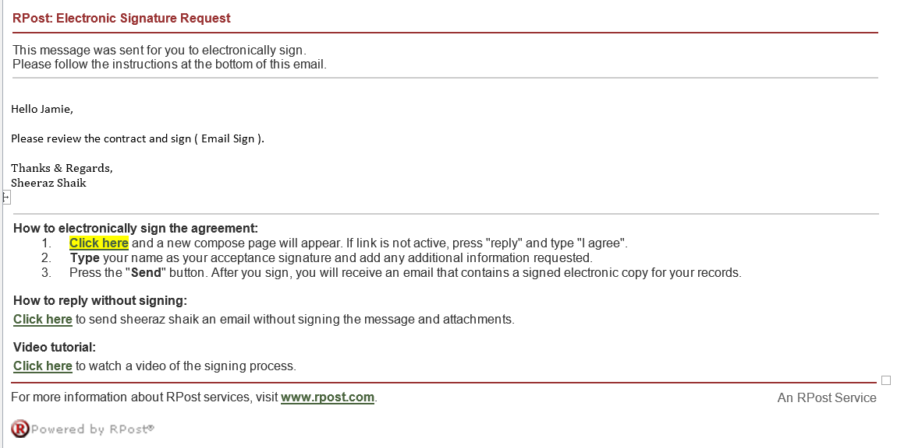

**Note:**

* Recipient can sign the document either by clicking on “click here” link or just reply and type as “I Agree”
* Recipient can even send an email without signing the message or attachments, by just clicking on second “Click here” link.
* Step 2 follows, once recipient clicks on reply button.

**Step 2: Refer the screen shot below, when user clicks on reply option:**

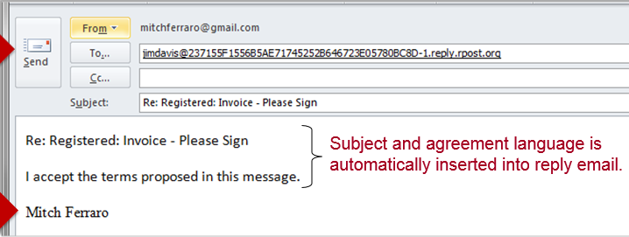

**Note:**

* The address in TO field routes the message back through the RPost system and associates it with original message sent and agreement.
* The number shown in the To field is the message id.
* The subject and agreement language is automatically inserted in reply email
* Step 3 follows , once recipient sends the reply

**Step 3: Refer the screen shot below for the eSignoff by Email – signed email:**

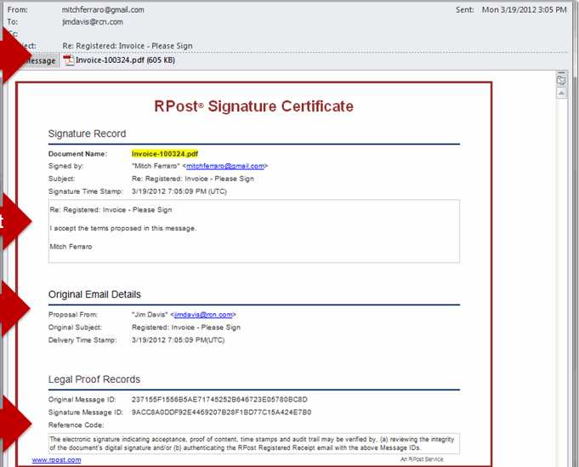

**Note:**

* Recipient receives the ESign-Off by Email – Signed Email, as soon as reply mail is sent
* E-Signoff Email contains the audit trail of the back and forth emails and the PDF is electronically signed by the recipient and digitally signed by RPost.
* E-Signoff PDF contains the original message and Signature certificate by RPost.
* E-Signoff PDF contains the Signoff date, at the bottom of each page in PDF file.

### Flow chart for Email Sign:



### Sequential Signing: (From Gmail App)

* E-Sign in Gmail App can be done in two ways , as below :

1. First Come – Send to all recipients at the same time .Recipients can sign in any order
2. Sequential: Send to recipients in the order listed in “TO” field.

* **First Come :**
* This option is same as Simple hand Sign, from any other app, where the contract will be sent to all recipients at the same time and the recipients can sign in any order.
* **Sequential Signing :**
* Sequential Signing sends the contract to all recipients in the same order, as included in ‘TO’ field.
* The contract will be sent to the next recipient in TO field, only after the previous recipient has signed the document.
* The contract will not be sent to the remaining Un-Signed Recipients, if any of the recipient declines the contract.
* Even in Sequential signing, the contract will be sent to all Cc and Bcc recipients as information only. All Cc and Bcc recipients should not be allowed to sign the contract.
* Cc and Bcc users should receive the sequential hand sign message at the same time, as sequential order is applicable only for TO recipients.
* For every new user created in back office , the sequential setting should be set as “N/A” and default value for N/A is No for sequential signing
* An encrypted sequential hand sign should behave same as encrypted hand sign in terms of settings and sending password emails etc.
* Any settings with respect to e-contract in control panel or from dialogue panel options are applicable to sequential singing as well.
* Sequential Signing is mainly applicable to hand sign. It’s just for workflow purpose for Email sign, as each recipient will be handled individually in email sign process.
* Even in sequential signing, original recipient can forward the hand sign message to a different recipient and they can accept the contract on behalf of original recipient.

### Flow chart for Sequential Hand Sign Message: (2 recipients)



### E-Contract 🡪Options tab 🡪

E-Contract options can be selected from Compose Email 🡪Send Dialogue panel 🡪 options button🡪E-Contract

* **Enable the E-Contract service:**
* If this option is unchecked, then user should not be allowed to select the E-Contract option (neither hand sign nor email sign) from send dialogue panel.

The E-Contract option in the send dialogue panel should be disabled

* All the other options in the Options🡪E-Contract should also be disabled, when this checkbox is not selected.
* **Hand-Sign with mouse method:**
* This option should get enabled only if the top option ‘Enable the E-Contract service ‘option is checked/selected
* Once hand-Sign with Mouse method option is selected here, then by default all the E-Contract documents should be sent as hand sign only.
* If this option is Un-checked here, then all the E-Contract emails should be sent as email sign only. ( provided if email sign is selected as default option )
* Note that, the default radio buttons gets hidden from the options tab, so that user should not be given an option to select any default options again, to avoid discrepancies.
* E-Contract option in send dialogue panel should be disabled with Email Sign as pre-selected option, as the Email sign is set as default value.
* **Sign using Email method:**
* This option should get enabled only if the top option ‘Enable the E-Contract service ‘option is checked/selected
* Once Sign using Email method option is selected here, then by default all the E-Contract documents should be sent as Email sign only.
* If this option is Un-checked here, then all the E-Contract emails should be sent as hand sign only. ( provided if hand sign is selected as default option )
* Note that, the default radio buttons gets hidden from the options tab, so that user should not be given an option to select any default options again, to avoid discrepancies.
* E-Contract option in send dialogue panel should be disabled with Email Sign as pre-selected option
* **Send all E-Contract emails encrypted according to current encryption settings**
* This option should get enabled only if ‘Enable the E-Contract service ‘option is checked
* Once this option is selected/checked here, then by default all the E-Contract documents should be encrypted , based on encryption settings ( Refer the Encryption section – Options tab 🡪 Encryption , for more details on encryption settings)
* **Pre select the E-Contract service by default**
* This option should get enabled only if ‘Enable the E-Contract service ‘option is checked.
* Once this option selected, by default e-Contract should be selected in the send dialogue panel, with hand sign or Email sign, as selected by the user.
* When this option is not selected, then by default the Standard radio button should get selected in Send Dialogue Panel.
* **Default Radio button**
* This option should get enabled only if ‘Enable the e-Contract service ‘option is checked
* Default radio buttons should appear, only when both “hand sign with mouse method” and “Sign using Email method” checkboxes are selected
* First radio button is to set the Hand sign as default econtract option
* Second radio button is to set the Email Sign as default econtract option
* Default radio buttons section should get hidden, when only the ‘Hand Sign with Mouse method “is selected (which means sender wants to send all econtract emails as Hand Sign only , and hence no need to select the default value again)
* Default radio buttons section should get hidden, when only the ‘Sign using Email method “is selected (which means sender wants to send all econtract emails as Email Sign only , and hence no need to select the default value again)

### Control panel Settings:

**Below are few of the Control panel settings with respect to E-Contract: (User Application Settings)**

**Control panel 🡪System 🡪 User 🡪 List 🡪 Search for specific user 🡪 Edit Application Settings**

* **E-Sign Show client code?**
* Set as YES

For Hand Sign: Client Code should get displayed

For Email Sign: Client Code should get displayed

* Set as NO

For Hand Sign: Client Code should get displayed

For Email Sign:

* Set as N/A

For Hand Sign: Client Code should get displayed, as default value for N/A is true

For Email Sign: Client Code should get displayed, as default value for N/A is true

Table below shows the behavior of E-sign show client code for Hand sign and Email sign:

|  |  |  |  |  |  |  |
| --- | --- | --- | --- | --- | --- | --- |
| CP Setting | N/A (Treated as Yes if not set) | | YES | | NO | |
|  | Hand Sign | Email Sign | Hand Sign | Email Sign | Hand Sign | Email Sign |
| If there is a client code, it will appear in the:  Subject Line (options only in available in Outlook button) | Yes (if set in Outlook) | Yes (if set in Outlook) | Yes (if set in Outlook) | Yes (if set in Outlook) | Yes (if set in Outlook) | Yes (if set in Outlook) |
| If there is a client code, it will appear in the:  Acknowledgement Email | Yes | Yes | Yes | Yes | No | No |
| If there is a client code, it will appear in the:  First Receipt (with Hand Sign) | Yes | Yes | Yes | Yes | No | No |
| If there is a client code, it will appear in the:  Second Receipt (with Hand Sign) | Yes | Yes | Yes | Yes | No | No |
| If there is a client code, it will appear in the:  Final e-contract email | Yes | Yes | Yes | Yes | No | No |
| If there is a client code, it will appear in the:  Final e-contract document/pdf | Yes | Yes | Yes | Yes | No | N/A |

* **E-Sign Sequential**
* Set as YES

For Hand Sign: All the recipients should receive the hand sign email sequentially in the same order as entered in ‘To’ list. (Next recipients in the list will receive the email, only if the previous recipient accepts the contract)

For Email Sign: There is no significant impact of sequential singing on Email sign process

* Set as NO

For Hand Sign: All the recipients in ‘To’ list should receive the hand sign email at the same time and any recipient can sign the contract irrespective of the order in the ‘To’ list. Its First come first serve basis.

For Email Sign: There is no significant impact of sequential singing on Email sign process

* Set as N/A

For Hand Sign: Default value of N/A is False for Sequential hand sign, hence it will be considered as NO only

For Email Sign: There is no significant impact of sequential singing on Email sign process

* **E-Sign Signature page First**
* Set as YES

For Hand Sign: In final e-contract document, Signature Certificate should get added as first page in the document.

For Email Sign: In final e-contract document, Signature Certificate should get added as first page in the document

* Set as NO

For Hand Sign: In final e-contract document, Signature Certificate should get added as last page in the document

For Email Sign: In final e-contract document, Signature Certificate should get added as last page in the document

* Set as N/A ( Default value for N/A is No)

For Hand Sign: In final e-contract document, Signature Certificate should get added as last page in the document, as default value is false.

For Email Sign: In final e-contract document, Signature Certificate should get added as last page in the document, as default value is false.

* **Annotation**
* Set as YES

For Hand Sign: On e-sign webpage , ‘Click to Type ‘ and ‘Click to Sign’ options should be displayed and enabled for user to enter any comments.

For Email Sign: Not applicable to Email Sign

* Set as NO

For Hand Sign: On e-sign webpage, ‘Click to Type ‘and ‘Click to Sign’ options should not get displayed

For Email Sign: Not applicable to Email Sign

* Set as N/A ( Default value for N/A is Yes )

For Hand Sign: On e-sign webpage , ‘Click to Type ‘ and ‘Click to Sign’ options should be displayed and enabled for user to enter any comments.

For Email Sign: Not applicable to Email Sign

* **E-Sign Contract Copy Destination**
* Hand Sign: Final E-Sign contract copy should be sent to the email address as added in this field.
* Partially Signed contract - Yes , even a partially signed contract copy should also be sent to the email address as added in this field
* Declined Contract - Yes , even a declined contract copy should also be sent to the email address as added in this field
* Email Sign - Final E-Sign contract copy should be sent to the email address as added in this field
* **E-Sign Contract Re-route Destination**
* Hand Sign: Final E-Sign contract should be rerouted to the email address as added in this field.
* Sender should not receive any final e-contract emails , as all the e –sign contract emails are rerouted to the mentioned email address
* Partially Signed contract - Yes , even a partially signed contract should also be rerouted to the email address as added in this field
* Declined Contract - Yes , even a declined contract copy should also be sent to the email address as added in this field
* Email Sign - Final E-Sign contract copy should be rerouted to the email address as added in this field
* **E-Sign expiration ( expiration time in days)**

Note: This feature is not yet implemented

* **E-Sign landing page**
* E-Sign landing page is for diverting the recipients to a new webpage, after they accepts/declines the contract.
* On staging environment, when recipients sign the contract, immediately rpost.com page loads. In the same way users want their own official webpages to be displayed, after the recipient action.

### Use cases for E-Contract (Hand Sign and Email Sign) features:

1. Send an e-sign document to multiple recipients in To, CC and BCC fields for email signature

**Expected Result:**

Sender receives the Acknowledgement email

Sender receives the

1. Send an e-sign document to multiple users, one recipient signs it within 2 hours, second recipient signs it after 2 hours and third recipient signs it after 30 days.

**Expected Result:**

Sender receives an email with the details of the first recipient and an option for the sender to retrieve the partially signed document

Sender receives the registered receipt after two hours with the current status of the message (Recipient 1 as delivered and opened, recipients 2 and 3 as Delivered to mail server/inbox)

Sender receives the open receipt for the Receipt 2, once the mail is opened by Recipient 2 after 2 hours.

Sender should not receive any open receipt for recipient 3, as the mail is opened after 30 days.

1. Send an e-sign document to multiple users , in To, CC and BCC fields for hand sign

**Expected Result:**

Only the recipients in TO field should be able to sign the document or “Click Here to Sign “option should be available only to ‘TO’ recipients

CC and BCC recipients should receive the copy of the econtract email, for information only. ‘Click here to Sign” link should not be available for Cc and Bcc recipients.

1. Send an e-sign document to two recipients in ‘To’ field for hand sign. One recipient signs the contract and other declines the contract

**Expected Result:**

Sender receives the mail as one recipient accepts the contract and another mail as recipient declines the contract

Sender receives the Registered Receipt as both the recipients have opened the message

Neither Sender nor recipients will receive any E-Sign off document, as one of the recipient has declined the contract

1. Sequential Signing : When Econtract is sent to multiple users in ‘TO’ field for Sequential signing

**Expected Result:**

EContract should be sent to the first recipient in ‘TO’ field for signing. Once recipient 1 signs the document, then again the contract is sent to second recipient in ‘TO’ list, in sequential order.

Sender should be receiving an individual email, as and when each recipient signs the contract, along with the option to retrieve the partially signed contract, till the last recipient signs the document.

Sender and all the recipients should receive the final esign-off document along with the signature certificate, once all the recipient’s have accepted the contract.

1. Sequential Signing: Econtract is sent to 2 recipients in TO field. Recipient 1 declines the contract. Does recipient 2 still receives the contract for signing?

**Expected Result:**

Sender and both the recipients should receive the declined notice directly.

Recipient 2 should never receive the econtract for signing, as Rec 1 has declined the contract already.

1. Recipient opens the econtract for signing, and keeps it open for more than 20 minutes.

**Expected Result:**

If the recipient keeps open the esignoff document, then session time out error should get displayed, and the recipient can again click on ‘Click here to Sign’ link from message to sign the contract.

**Note: Session time out for econtract is 20 minutes**

1. Sequential Signing: Econtract sent to two recipients in TO field, Recipient 1 keeps the contract open for 20 minutes. Whether the recipient 2 receives the econtract for signing after 20 minutes or only after recipient 1 signs the contract?

**Expected Result:**

1. Econtract sent to two recipients in TO field. Can both the recipients sign the document at the same time?

**Expected Result:**

No, Recipients cannot sign the contract at the same time, it has to be signed one after another.

The second recipient will see the message as “

1. Can the same recipient sign the contract more than once?

**Expected Result:**

No, the recipient can sign the contract only once. If recipient tries to resign it, error message should get displayed as “You already signed this document”

1. If the sender retrieves the partially signed contract, whether the Un-signed recipients can still sign the document?

**Expected result:**

No, the other recipients should not be allowed to sign the document, once the partially signed document is retrieved by the sender.

1. Can EContracts be forwarded to different recipients?

**Expected Result:**

Econtracts can be forwarded, just same as normal emails.

But the email address in final esign off document will be of recipient, who forwarded the econtract.

Recipient, who forwarded the econtract, will not be able to sign the document, as it’s already been signed by other users.

1. In ESign off document, if user is just entering name and not the signature, what gets displayed in signature area in final sign off document?

**Expected Result:**

When recipient just enters name without signature, Then Name gets displayed in the Signature section of the final ESign-off document.

Both Signed By field and Signature area shows the Name only, as entered by the recipient.

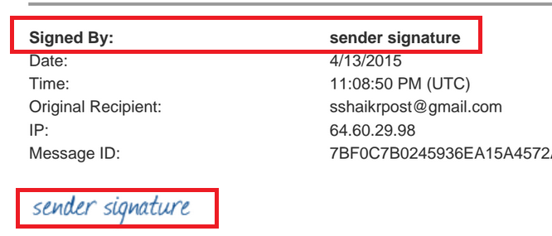

1. In ESign off document, if user is entering both name and signature, what gets displayed in signature area in final sign off document?

**Expected Result:**

When recipient enters both name and Signature in the Final step of e sign off, then Name gets displayed in the Signed By section and Signature reflects in Signature Section.

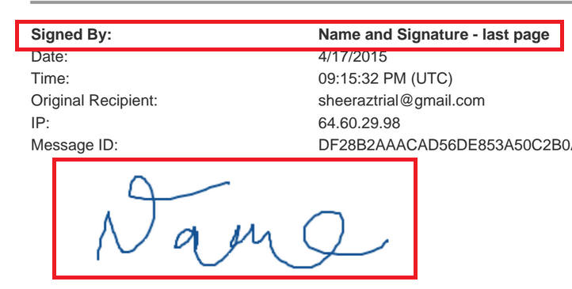

1. What is a Second Receipt?

**Expected Result:**

Second receipt gets generated, after all the recipients accepts the contract.

It is a proof that the final econtract document is sent to all respective recipients including sender.

### Encrypt – send end-to-end encrypted for extra privacy

* Encrypting sensitive emails and attachments for quick-and-easy security and legal compliance and enhance the attorney-client privilege by protecting from downstream data breaches.
* SecuRmail can be defined as Registered Email + Encryption for end-to-end privacy with proof of encrypted delivery.
* Sender is protected from downstream data breach with auditable proof for compliance
* Receiver accesses encrypted email right in their inbox, no links ; high response rate
* Receiver may open and view encrypted email and attachments online or Offline.
* Regardless of any sending options, recipient always receives the email directly delivered to his inbox.
* Recipient receives the message with a banner as “Encrypted Email “ , as below :



* For an encrypted email, Recipient receives two messages, first one is the secure message with password to open the message and second one is the actual encrypted message.
* The encrypted message can be opened only with the password, provided in the first mail.
* The password can be either a system generated password or a user defined password.
* Recipient can view the encrypted message any time, either offline or online with the correct password.
* As per the design, password mail should go first to the recipient and then the encrypted message mail.
* The message will never be locked or blocked, even after multiple entries of incorrect password.
* Encrypted emails can be sent to multiple recipients and password will also be sent individually to all these recipients along with the encrypted mail.
* Recipient has given an option in the encrypted mail to request for the decryption password, incase if the recipient forgets the password or has not received the password email.

Same password will be sent to recipient to the same email address.

The recipient is not provided with an option to request for the password to send it to a different email address.

* Recipient has given an option in the encrypted mail to permanently set their decryption password for all future encrypted registered email messages.

**Encryption Service:**

* Compose Email
* Attach the documents , if applicable
* Click on Send Registered Button and open send Dialogue Panel
* Select Encrypt option
* Send the Email/Message
* Sender receives an Acknowledgement email , that message has been sent
* Recipient receives two messages, first one is the secure message with password to open the message and second one is the actual encrypted message.
* Recipient opens the message with the password provided in message 1
* If the encrypted message is an econtract, then both the parties’ sender and recipient will receive the eSignOff documents.
* Sender receives the registered receipt as a proof of delivery, within two hours of time along with the current status of the message.

**Note:** For more details on Registered Receipt, refer the registered receipt section

**Refer the screen shot below for the Encryption option in Send Dialogue panel:**

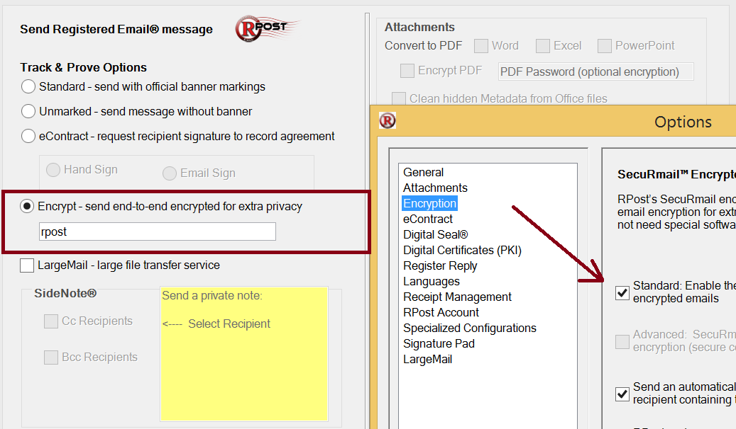

#### More information on Encryption:

* **Encryption is broken-down in two parts as below:**

1. Sender RPost

1. RPost Recipient

* **Email message from Sender to RPost is again divided in three modes as below:**
* **Executive Mode**

In executive mode, the message is encrypted locally at the sender’s desktop or device, ensuring encrypted delivery straight through to the recipient’s desktop. It protects from the potential of data breaches both within the senders in-house or outsourced email system, and external while in transport across the internet and within the recipients email system.

* **Network Mode**

In network mode, the message is encrypted at least from the edge of the sender’s network to at least the sedge of the recipient’s network. This permits corporate filtering functions to continue to scan email within the senders or recipients organization.

* **Policy Mode**

In policy mode, the message is automatically encrypted at the senders outbound mail gateway based on message content or other criteria.

* **Email message from RPost to Recipient is divided in two modes as below:**
* **Message level Encryption**

RPost uses an AES encrypted PDF salted with a unique decryption code. The email body text is converted to PDF and encrypted with the attachments embedded inside the PDF while maintaining their native format. The receiver views the encrypted Registered Email message inside a PKI digitally signed PDF.

* **TLS Encryption Setting ( Option setting if TLS is available)**

If the sender has selected this option, RPost tests to determine if the receiver server supports and will accept at the moment a secure connection for TLS encrypted transmission. If it can, RPost delivers the message via the encrypted connection to the recipient server and the message displays in the recipient’s inbox in a standard email message form with markings on it so the sender knows that it had been transmitted encrypted and contains sensitive or protected information. If TLS is unavailable, the message is sent via Message Level encryption.

### Options tab 🡪 Encryption:

Encryption options can be selected from Compose Email 🡪Send Dialogue panel 🡪 options button🡪Encryption

* **Standard : Enable the option to send SecuRmail encrypted emails:**
  + This option enables the user to select the encryption radio button in Send Dialogue Panel.
  + If this option is unchecked, then user should not be allowed to select the encryption option from send dialogue panel nor to enter the password in the textbox.
  + The encryption option in the send dialogue panel should be disabled , if the checkbox is not selected/un checked
  + All the other options/checkboxes in the Options🡪Encryption should also be disabled, when the top checkbox is not selected.
* **Advanced : SecuRmail service without local encryption (secure connection to RPost required )**
* This option is disabled as of now in options tab
* **Send an automatically generated email to the recipient containing the decryption password**
* When this checkbox is selected /checked in options, the recipient receives an automatically generated decryption password to open the encrypted secure pdf document.
* Once this option is set , then the text box to enter the user generated password for encryption in send dialogue panel should be disabled with the text as “ System generated password”

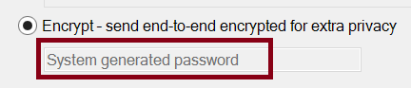

* If this option is unchecked /not selected, then the text box for Encrypt should be activated or enabled for the user to enter User generated password.

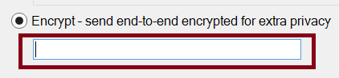

* **Note:** The recipient should receive the user generated password, as set by the sender in a separate email to open the encrypted email.
* With this option as checked, either the sender can opt for randomly generated decryption password or with a user generated password.
* **RPost system generates random decryption password**
* This option is enabled, only when the sender has activated the above option i.e. “send an automatically generated email to the recipient containing the decryption password”
* A random decryption password will get generated and is forwarded to recipient, to open the encrypted email, with this option.
* Once this option is set , then the text box to enter the user generated password for encryption in send dialogue panel should be disabled with the text as “ System generated password” – Refer the screen shot above
* **Note:** if the Recipient has permanently set a decryption password for all future emails, then this randomly generated password should not be sent to recipient.
* **Pre-select the SecuRmail encryption option by default**
* Once this option is enabled , then the encrypt option should be selected by default in Send Dialogue panel
* As this option is set , all the emails should be sent as encrypted emails ( either with system generated password or user generated password)
* If this option is not selected/un-checked, then by default Standard option should get elected in Send Dialogue panel.

### Control Panel Settings:

**Below are few of the Control panel settings with respect to Encryption: (User Application Settings)**

**Control panel 🡪System 🡪 User 🡪 List 🡪 Search for specific user 🡪 Edit Application Settings**

* **Send Password :**
* **Set as YES**

For Encryption - System generated password, separate password email should be sent to recipient with the system generated password to open the encrypted message.

For Encryption – User generated password, separate password email should be sent to recipient with the user set password to open the encrypted message.

* **Set as NO**

For Encryption - System generated password, separate password email should be sent to recipient with the system generated password to open the encrypted message (As this is randomly generated password, even sender might not be knowing this password)

For Encryption – User generated password, separate password email should not be sent to recipient to open the message.

* **Set as N/A**

When set as N/A, This gets overwritten by the options selected by the sender or based on Application, Domain settings.

**Note:** If the recipient has set the permanent decryption password, then the system generated password nor the user generated password should be sent to that recipient.

* **Set Password :**
* **Set as YES**

For Encryption – Either System generated password or User generated password, recipient should receive an option to set their own decryption password for future encrypted registered email messages with a “Click here” link.

The recipient should be diverted to Change password page to set the own password

* **Set as NO**

For Encryption – Either for System generated password or user generated password, recipient should not receive the link to set their own decryption passwords.

* **Set as N/A**

When set as N/A, This gets overwritten by the options selected by the sender or based on Application, Domain settings.

**Note:** If the recipient has already set the permanent decryption password, then the option to set the own decryption password should never be sent to this particular recipient.

* **Retrieve Password :**
* **Set as YES**

For Encryption – Either for System generated password or User generated password, recipient should receive an option to retrieve the decryption password with a “Click here “link.

The password should be mailed to the same recipient email address, from where the retrieve password link is clicked.

The recipient can retrieve the password any number of times. There is no limit or expiry set for the retrieval of password.

* **Set as NO**

For Encryption - Either for System generated password or User generated password, recipient should never receive an option to retrieve the decryption password.

* **Set as N/A**

When set as N/A, This gets overwritten by the options selected by the sender or based on Application, Domain settings.

* **TLS :**
* **Set as YES**

For Encryption – Either for System generated password or User generated password, recipient should receive the message through TLS.

I.e. the recipient should not receive any decryption password and also the banner says “Transmitted Encrypted”

* **Set as NO**

For Encryption – Either for System generated password or User generated password, recipient should not receive the message through TLS.

I.e. recipient should receive the decryption password to open the encrypted email.

* **Set as N/A**

When set as N/A, this gets overwritten by the options selected by the sender or based on Application, Domain settings.

### Use cases for Encryption:

1. Recipient has set a permanent decryption password for all future encryption emails. If the recipient clicks on “retrieve password link “, what is the expected result?

**Expected Result:**

Recipient should receive the randomly generated password (Need further confirmation from Alex)

1. Recipient has set the permanent decryption password for all future encryption emails.

Still does the recipient receives the randomly /user generated password emails to open the encrypted emails?

**Expected Result:**

Recipient should not receive the decryption passwords for any future encrypted emails, as recipient has set the permanent decryption password.

1. For a recipient, to set the permanent decryption password, does the recipient need to be a Trial user or registered user?

**Expected Result:**

Any recipient can set their own password, regardless of trial user or registered user.

### Large-Mail – Large file transfer service

* Large size documents , i.e. up to 200MB can be sent securely by using Large-Mail service
* Trial users can send large files by using Large-Mail service for up to 100MB
* Registered users can send large files for up to 1GB ( on request with RCS System)
* Large-Mail service can be used for any file types like Word, Excel, PPT, PDF etc.
* Recipients will be provided with a 14-day pick-up window to download the large files
* All the files will be purged from RPost system , after 14 days
* Senders can set an option in control panel, to send reminder emails to recipients. Based on this setting, recipients will receive Large-Mail download reminders.
* Sender receives a notification, once the recipient has downloaded the large files.
* Sender has an option to send encrypted large mails. Recipient receives the mail in an encrypted pdf i.e. the download link will be included in password protected pdf file, from where the user can download the large files
* Sender has to register through RMail to use the Large-Mail feature from Outlook service, Login details are required to send a large mail from Outlook.

**Note:** Refer the control panel documentation for Large-Mail settings in control panel.

### Options Tab 🡪 Large-Mail

Large-Mail options can be selected from Compose Email 🡪Send Dialogue panel 🡪 options button🡪Large-Mail

* **Enable the option to send emails with large attachments using Large-Mail service**
  + This option enables the user to select the Large-Mail checkbox in Send Dialogue Panel.
  + Once Large-Mail option is selected from Send Dialogue panel , then Add Files button should appear , next to Large-Mail-Large-Mail Transfer service
  + If this option is unchecked, then user should not be allowed to select the Large-Mail option from send dialogue panel nor the option to select files.
  + All the other options/checkboxes in the Options🡪Encryption should also be disabled, when the top checkbox is not selected
* **Pre-select the Large-Mail option by default**
* Once this option is enabled, then Large-Mail checkbox should be selected by default in Send Dialogue panel
* As this option is set, all the emails sent through Send Registered button goes as Large-Mail.
* If this option is not selected/un-checked, then sender has to explicitly select the Large-Mail option from Send Dialogue panel as and when required.
* **Login required for Service**
* Sender has to be registered through R-Mail to use Large-Mail service. And these login details are required to send a large mail from Outlook service.
* Sender can register by clicking on Register button and the user will be directed to RMail page ( Rmail.rpost.com)
* Sender can save the email address and password , to be used for all Large mails , sent from Outlook
* **Automatic Activation**
* This option is enabled to automatically send the email as Large-Mail, when the attachment size goes beyond the size limit , as set here
* The user can set the attachment size from 0MB to 200MB and the emails will be sent as Large-Mail ,once the attachment size reaches this limit
* **Learn More button**
* Learn More button should directed the user to RPost.com , to get more details on all services provided by RPost.com

### Control panel Settings:

**Below are few of the Control panel settings with respect to Large-Mail: (User Application Settings)**

**Control panel 🡪System 🡪 User 🡪 List 🡪 Search for specific user 🡪 Edit Application Settings**

* **Large-Mail download Expiration (In days between 1-90)**
* Large-Mail download link expires, after the value set in this field.
* If the value is set as 10 days , the large mail download link should get expired in 10 days
* Error message should get displayed, when zero (0) value is set in this field. Expiration days should be more than 0
* **Large-Mail download reminder (X days before expiration)**
* A notification email should be sent to recipient, before x number of days, as set in this field.
* If the value is set as 10 days , then large mail download notification should be sent to the recipient as “ large-mail download reminder notice”
* The value set for large-mail download reminder field should be less than the value set for large-mail download expiration.
* **Send Download Notice ( Default value of N/A is YES)**

**Set as N/A:**

Sender should receive a notification email, as recipient has downloaded the attachments, sent in a large-mail

**Set as YES:**

Sender should receive a notification email, as recipient has downloaded the attachments, sent in a large-mail

**Set as NO:**

Sender should not receive a notification email, when recipient has downloaded the attachments, sent in a large-mail

### Use cases for Large-Mail:

1. Sender sends multiple files , say 100 attachments in a single mail , of 1MB each file

**Expected Result:**

Registered user can send up to 200MB as a Large-Mail, and up to 50 attachments in a single mail.

1. Sender sends an empty file as large mail

**Expected Result:**

Recipient still receives the empty file as large mail.

1. Trial user , sending a large mail above 100mb

**Expected Result:**

1. Is there any limit on how many large mails can be sent per user or on per day?

**Expected Result:**

1. Sender sends an Encrypted email as large mail

**Expected Result:**

Recipient receives the mail in an encrypted pdf i.e. the download link will be included in password protected pdf file, from where the user can download the large files

1. Can a sender send an e-contract by using Large-Mail service?

**Expected Result:**

No, the e-Contract option will be disabled, as and when sender selects the Large-Mail option from Send Dialogue panel.

### Side Note

* Side notes option gives the flexibility of sending a message only to CC and BCC recipients.
* Side Notes option will be enabled /activated only if there are any recipients in CC and BCC fields. i.e if there are no recipients added to BCC filed, then only CC check box should be enabled and BCC checkbox should be disabled in Side Notes section.
* Sender can select either CC or BCC or both to send the same message
* User can enter the message in the ‘Send a Private Note ‘ section , which will be delivered to CC, BCC recipients
* Side notes should be delivered to all recipients in CC or BCC fields, when multiple recipients are available in CC or BCC fields.
* Sender can enter a maximum of 512 characters in side notes message
* The recipient in “TO” field should never receive the Side Notes
* There is no specific format to be followed for side notes. Sender can compose it like any other normal message.
* Side notes supports all characters, numbers and special characters. There is no restriction on any font, size etc.

### Options Tab 🡪 Side Note

Side Notes options can be selected from Compose Email 🡪Send Dialogue panel 🡪 options button🡪General Tab 🡪 Side Notes option

* **Enable the option to add custom private notes sent to only the Cc and Bcc recipients**
* This option enables the user to send side notes to CC and BCC recipients
* If this option is unchecked, then user should not be allowed to select the Side Notes option from send dialogue panel nor the enter the message

### Use cases for Side Note

1. Sender selects CC recipients and sends a side note, but there are some recipients in BCC field as well. Whether the BCC recipients will also receive this side notes?

**Expected Result:**

Side notes should be delivered only to CC recipients, as sender has explicitly selected CC option for side notes.

1. Sender sends side notes to CC and BCC recipients along with Encrypted registered email

**Expected Result:**

Side notes should be delivered to CC and BCC recipients in the email body of an encrypted email

1. Sender sends side notes to CC and BCC recipients along with eContract

**Expected Result:**

Side notes should be delivered to CC and BCC recipients in the email body of an encrypted email

1. Sender sends side notes to cc and BCC recipients along with LargeMail service

**Expected Result:**

Side notes should be delivered to CC and BCC recipients in the email body of the LargeMail

1. Sender sends side notes to CC and BCC recipients along with Encrypted LargeMail

**Expected Result:**

Side notes should be delivered to CC and BCC recipients in the email body of an encrypted LargeMail

1. CC or BCC recipient clicks on reply all, then verify if the side notes is included or not in the message history?

**Expected Result:**

When the CC or BCC recipient’s clicks on Reply All option, then the side notes should be included in the message history (need confirmation from Alex)

### More>> Options:

* Sender can select more options by clicking on MORE<< button
* More options includes Attachments, Register Reply, Client reference Code and Sender Signature etc., explained as below.

### Attachments

* **Convert to PDF**
* Convert to PDF option gets enabled , only when there are any attachments in the message
* If a word document is attached , then only Word option gets enabled , same behavior for excel and power point documents as well
* If any other document types like text file , xml file are attached , then none of the checkboxes should be enabled to convert to pdf
* Note: When a pdf document is attached, then also none of the options should get enabled.
* **Encrypt PDF**
* This option encrypt PDF gets enabled, only if there are any attachments and Convert to PDF is selected.
* Sender can enter the password in the textbox, which will be used to unlock the pdf document.
* Note that, recipient will not receive any password email, for this feature.
* Its Sender’s responsibility to inform the password to all recipients beforehand.
* Encrypt PDF gets enabled only for word, excel and Power point attachments only.
* **Clean Hidden metadata from office files**

This option clears all the metadata from the attachments (applicable for office files)

* **Zip compress attachments**
* This option gets enabled, only if there are more than one attachments in the message
* This option compresses all the attachments to a zip folder.
* Zip compress option gets enabled only for Standard / Un-marked options only
* This option gets disabled , for e-contract and encryption services

### Options Tab 🡪 Attachments

* + **Convert to PDF**

**Enable the option to convert MS office attachments to PDF en-route**

**Pre-Select the convert to PDF option by default**

* When this option is selected here, convert to PDF gets enabled in Send dialogue panel and will be selected/checked by default.
* All the attachments will automatically get converted to pdf documents.
  + **Metadata Cleaning**

**Enable the option to clean hidden metadata from MS Office files en-route**

**Pre-Select the metadata cleaning option by default**

* When this option is selected here, Metadata cleaning option gets enabled in the Send dialogue panel and will be selected/checked by default.
* All the MS office files will be filtered and hidden metadata gets cleaned up, before sending to recipient.
  + **File Compression**

**Enable the option to zip compress file attachments en-route**

**Pre-Select the zip compress option by default**

* When this option is selected here, Zip compress attachments option gets enabled in the Send dialogue panel and will be selected/checked by default.
* All the attachments zipped, before sending to recipient.

### Use Cases for Attachments

1. Can I send an encrypted email with Encrypt pdf option as well?

**Expected Result:**

No, Encryption is converting the attachments to password protected document. So there is no significance of again using encrypt pdf option.

Also note that when encryption option is selected, then by default encrypt pdf option gets disabled.

1. Can I send text document , pdf documents by selecting encrypt pdf option

**Expected Result:**

No, encrypt pdf option gets enabled only for Word, excel and power point attachments.

### Register Reply

* + Receive proof of content & time of replies to this email
  + Register Reply option gives the feasibility for the recipient to reply as a registered message, even though they are not in RPost system.
  + The recipient reply gets diverted through RPost system as a Registered message
  + Sender will be charged the units for all the register replies from recipients
  + Recipient will not receive any Acknowledgment nor receipt emails.
  + Original Sender receives all Acknowledgment and receipts for all register reply messages
  + Register Reply option can be included with encryption, hand sign, large-mail etc.

**Refer the table below, for Register Reply:**

|  |  |  |
| --- | --- | --- |
| Service | Register Reply | Secure Reply |
| Registered/Unmarked | Available when checked |  |
| Encryption | Available when checked | Available inside the PDF or email template. |
| E-Sign | Available when checked |  |
| Large-Mail | Available when checked |  |

### Options Tab 🡪 Register Reply

* + **Enable the option for the recipient to reply to email as a Registered Email message**
  + When this option is selected here , Register Reply gets enabled in Send Dialogue panel
  + **Pre-Select the Register Reply option by default**
  + Register reply option gets selected by default in Send Dialogue panel and all the messages will be sent as register reply messages

### Use Cases for Register Reply

1. Sender sends a registered message to multiple recipients with register reply option, then is Register Reply option applicable for all recipients?

**Expected Result:**

Yes, Register reply option gets applicable to all the recipients in To, Cc and Bcc fields

1. Sender sends out the Register Reply message to Recipient 1 and recipient 1 forwards the message to recipient 2, and recipient 2 clicks on Reply All and replies to message.

**Expected Result:**

Reply or Reply All should send the reply to only recipient 1 and should not be a register reply. Sender will not get charged in this scenario

1. Sender sends out the Register Reply message to Recipient 1 and Recipient 2, Recipient 1 replies to sender and adds a new email address in cc or bcc field.

**Expected Result:**

The reply to sender should come as register reply and for the new email address added, the message should go as normal message.

Sender gets charged only for one reply from sender

1. Sender sends out the register Reply message to Recipient 1. Recipient 1 replies to the message. Sender replies to same message and again recipient replies and the cycle goes on and on. Is there any limit on when this cycle stops?

**Expected Result:**

No, there is no limit on the register reply cycle. But every time the sender’s units gets charged for each reply from recipient.

### Client/Reference Code

* Client /reference Code , is like a reference for the sender to keep track of the messages with a reference code or client code
* Sender can enter any code from Aa –Zz , 0-9 and special characters as well
* All the client codes gets stored in the specified folder and also shown in the dropdown , for quick reference
* This Client /reference code will appear in the Acknowledgment email, Receipt, delivery receipts, usage reports etc.

### Options Tab 🡪 Receipt Management

Client Code options can be selected from Compose Email 🡪Send Dialogue panel 🡪 options button🡪Receipt Management Tab

* **Enable Client Code**
  + This option enables the sender to add Client/Reference Codes to the email message
  + If this option is unchecked , then the sender should not be allowed to add the client code to message , the dropdown option should be disabled in send dialogue panel

* **Add Client Code to end of email subject**
  + Once this option is selected , then the Client code /reference code should get appended at the end of the email subject line
  + Sender can enter new client codes or can select from existing client codes

* **Always require Client Code**
  + This option enables the sender to check for the client code on all registered messages. I.e. sender should not be allowed to send messages without any client code associated to the email message.
  + Error message should get displayed , if user clicks on send button without assigning Client code for the message , with this option selected
  + If this option is unchecked , then system will not check for any client code for the message
* **Client Codes**
  + Sender can add /delete multiple client codes from this option , and all the added client codes should appear in the dropdown in send dialogue panel
  + Sender can store all these client codes in a specified location by selecting the browse option.
* **Send copy of my Registered Receipt emails to this address**
  + This option enables the sender to send a copy of the registered receipt to another email address as well, as provided by the sender in the text box. The registered receipt will then be sent to sender and also to the email address provided by the sender.
  + If this option is not selected from options tab, then registered receipt should be sent only to the sender address.

### Control panel Settings:

**Below are few of the Control panel settings with respect to Receipt Management: (User Application Settings)**

**Control panel 🡪System 🡪 User 🡪 List 🡪 Search for specific user 🡪 Edit Application Settings**

* **Receipt Copy Destination** 
  + A copy of the Registered Receipt will be sent to another email address, as provided in the text box.
* **Receipt Re-route Destination**
  + The registered receipt will be forwarded to the email address, as specified in the text box.
  + Sender will not receive any registered receipt , as the receipt is getting re-routed to another email address, as provided in this settings ( In case if the sender email address and the provided email address is different)

### Use cases for Client/reference Code

1. Can a sender use the same client code for multiple emails?

**Expected Result:**

Yes, the sender can use the same client code for multiple emails and also with multiple recipients as well.

1. If the same sender address is updated in receipt copy destination, what happens?

**Expected Result:**

Sender should receive only one Registered Receipt, but not twice.

### Sender Signature & Authentication

* **Sign & Time-stamp with Digital seal mark**
  + This option allows the sender to include the own signature as authentication.
  + The sender signature will get added at the right corner of each page of the pdf , to maintain the authentication of the attachment
  + When the message is sent with Digital Seal mark, the recipient will get the feasibility of authenticating the original message itself. (Generally sender will send the receipts for authentication , not the recipient in all other services).

Recipient receives the authentication results, along with the original message

### Options tab 🡪 Signature pad

* **Enable the option to add your signature to registered Email messages**

This Option enables the sender to add the Signature to the email message

* **Sign all Registered Email messages with saved signature**

This option enables the sender to send all the registered messages, by including saved signature

* **Draw your signature**

Sender can draw and save the signature here for all future messages

* **Add your personal signature file (JPG ,PNG,GIF)**

Sender can upload the personal signature here by selecting the file.

### RPost link: Sign email and PDF attachments

* Sender can include their mouse drawn signatures by using this option
* Sender can save and include the same signature multiple times by clicking on Add button
* The signature can be viewed in expanded form by using Expand feature.

### Options Tab 🡪 General

**Proof Records**

* **Receive Acknowledgement emails confirming processing of message**
* When this option is unchecked here , then sender will not receive any acknowledgment emails
* **Save my registered receipt emails in a separate “Receipt” folder**
* When this option is selected here, all the receipts gets diverted to Receipts folder.
* Only Acknowledgment emails, contracts etc. gets in Inbox folder and receipt goes to receipts folder.
* If this option is unchecked here, then even receipts gets stored in inbox only
* **Button position**

This is disabled in Options

**Unmarked Options**

* **Unmarked : Allow the option to send Registered Email messages without banners**
* When this option is selected/checked here, then Un-marked option gets enabled in Send dialogue panel
* If this option is unchecked here, then Un-marked option should be disabled in Send dialogue panel
* **Pre select the unmarked option by default**
* When this option is selected/checked here, then Un-Marked option will be the default option for all messages

**Side Note**

* **Enable the option to add custom private notes sent to only the CC and Bcc recipients**
* When this option is selected/checked here, side notes option gets enabled in Send dialogue panel , to include side notes for Cc and Bcc recipients
* When this option is unchecked here, Side notes option will be disabled in Send dialogue panel.

### Options Tab 🡪 Languages

* RPost currently supports 7 languages and the languages are as below :
  + English
  + Dutch
  + French
  + German
  + Italian
  + Portuguese
  + Spanish

### Options Tab 🡪 RPost Account

* This tab gives the information about the RPost user account like what is the Authenticated Address, user account, Distributor code etc.

### Options Tab 🡪 Specialized Configurations

* Specialized Configurations tab is disabled as on now.

### Apps tab

* Apps tab should lead the user to [www.rpost.com/Apps](http://www.rpost.com/Apps) /market -place
* Apps tab gives the information about multiple apps , supported by RPost.com

### RPost Version number and Help button

* Version number of the outlook button is shown in this section as version # 8.9.15.0
* Help icon should lead the user to [www.rpost.com/resources/quick](http://www.rpost.com/resources/quick) guide page

# Acknowledgement Email

* **Acknowledgement Email for Trial users:**
* Sender receives an Acknowledgement email for all the sent messages , as a confirmation that message is sent to recipients
* All the Acknowledgment emails can be identified with a Subject Line as “ Ack : Subject ( Sent Registered)”
* For a Trial user, Acknowledgement email gives the record of how many registered messages are left in the trail /free account in the message body.
* Acknowledgement email also provides a link for the sender to convert from Trial to a Registered user by purchase a RPost service plan , by using the link “ [www.rpost.com.signupnow](http://www.rpost.com.signupnow)”
* Acknowledgement email provides the high level details of the message sent by the sender , like
* Subject of the email
* To Recipients list
* Cc Recipients list
* Time when received by the registration service (Both UTC and Local times)

UTC – Coordinated Universal Time

Local Time – Local time of the sender

* Message ID – Which is a unique id for each message
* Network ID –
* Client Code – As entered by user, while sending the message
* Note, as Bcc addresses will be included in the receipt email.
* Acknowledgement emails just confirms that email is only transmitted to recipient, but doesn’t confirm that message is opened by the recipient.

(The time, when recipient opened the mail will be captured in registered Receipt or Open receipt)

**Acknowledgement Email for the Trial user is as below:**

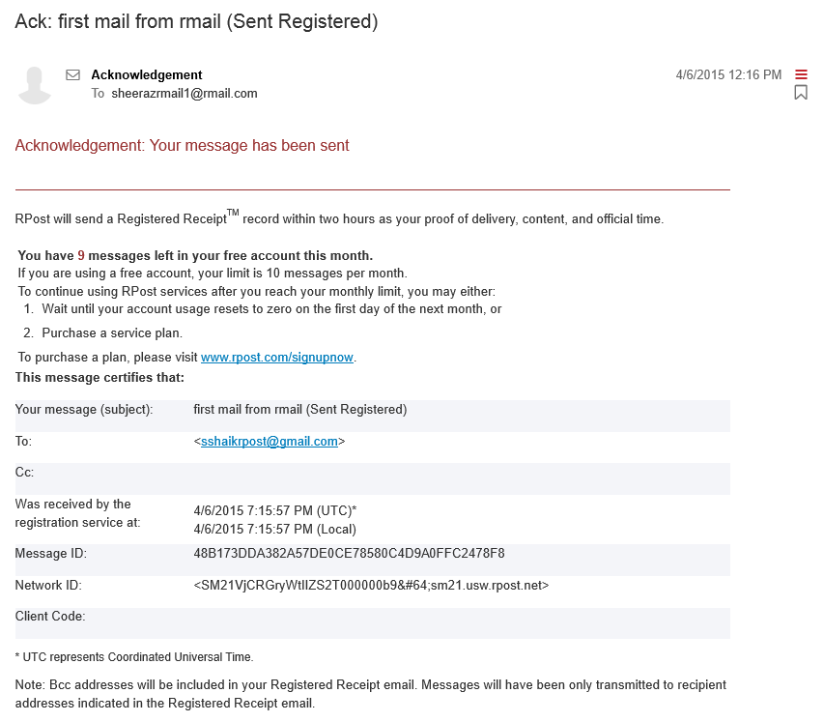

* **Acknowledgement Email for Registered users:**
* Acknowledgement email for the Registered users is same as Acknowledgement email for trial users , other than record of messages left for the user
* Acknowledgement emails just conforms that email is only transmitted to recipient, but doesn’t confirm that message is opened by the recipient.

(The time, when recipient opened the mail will be captured in registered Receipt or Open receipt)

**Acknowledgement Email for the registered user is as below:**

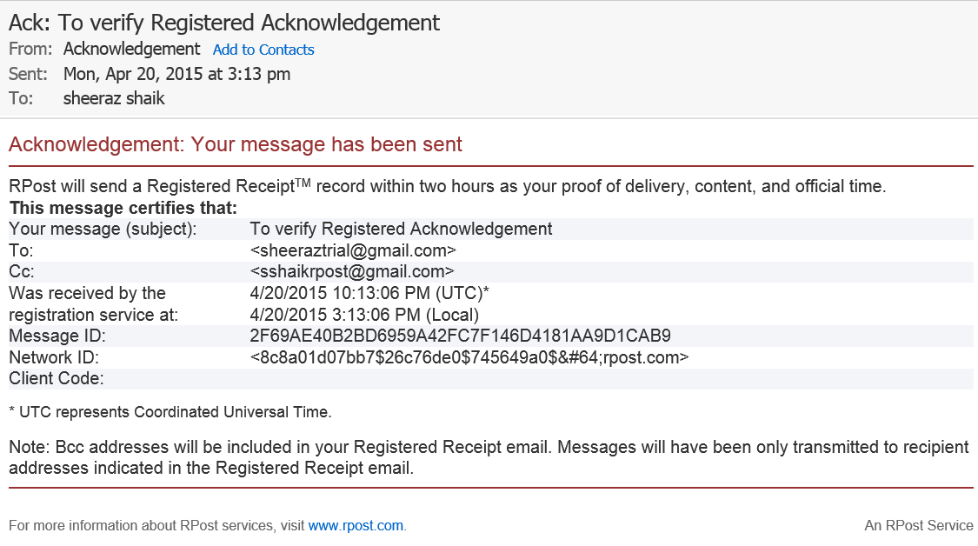

### Use cases for Acknowledgement Email:

1. When a Registered reply message is sent, who will receive the Acknowledgment email?

**Expected Result:**

Original Sender should receive all the Acknowledgement emails, recipient should not receive any Acknowledgement nor receipts.

# Registered Receipt

* Registered Receipt contains the information to prove delivery , content and time of the email transaction , which includes a banner as “Registered Receipt”
* Sender receives a Registered Receipt ,within two hours as a proof of delivery , that all the recipients had opened the message
* Registered Receipt includes all the recipients of the mail i.e. , TO , Cc and Bcc recipients
* Registered Receipt will be generated as and when all the recipients opens the message , and will be sent to sender as confirmation
* Maximum time duration defined to initiate the Registered Receipt is “2 Hours “. i.e., Receipt will be generated irrespective of whether recipient has opened the message or not, based on the current delivery status of the message.
* Registered Receipt to sender should include two attachments i.e. , Delivery Receipt.xml and HTMLreceipt.html
* Delivery Receipt:
* HTML Receipt :

The HTML Receipt file contains the original email and attachments, audit trial, delivery information, digital fingerprints, and times. This information is cryptographically stored and embedded in the registered receipt email, not with RPost.

**Note:** RPost dos not store copies of receipt or email content by Default.

* **Different levels of Delivery are :**
* **Delivered and Opened:**

This status will appear, when the message is successfully delivered and opened by the recipient.

Opened time gets captured in the Opened option, for this Status.

HTTP – IP address of the recipient gets captured in the Details option as below:

**MUA+HTTP-IP: 167.7.176.5**

**Open Detection methods:**

MUA – mail user Agent (mail client)

HTTP: Image Tracking

* **Delivered to Mailbox:**

This status will appear, when the message is delivered only to Mailbox.

Opened time should be blank in this case.

Mail box details gets captured in the Details option.

* **Delivered to Mail server:**

This status will appear, when the message is delivered to Mail Server.

Opened time should be blank in this case.

Mail Server details gets captured in the Details Option along with server IP etc.

* **Delivery Failure**

This status will appear, when there is a delivery failure of the message.

Delivered Time and Opened time should display as blank in this case.

Common causes of a delivery failure may include:

* Mailbox full
* Bad Recipient Address
* Email too large for recipient’s mail system
* Recipient’s mail system is down
* Receipt should also include the time, when message was received by RPost from sender.
* Received by RPost time should always be earlier than the delivered time to sender, as RPost first receives the message, then it’s delivered to recipient.
* Message ID , which is unique for every message should be same as of Acknowledgement mail
* Receipt should also include the attachment details like how many files were sent in the message along with the file sizes
* Receipt should also include the complete message size, which includes message, attachments, headers added by RPost etc.
* Delivery Audit trail should also be included in the Receipt ( Bottom part of the Receipt)

RPost records the delivery audit trail or transaction metadata. This is a recording of the SMTP dialogue as well as other transmission data, and is a statement of fact as to what transpired. This information is recorded in original form and is then translated by RPost for users to quickly understand the delivery status

**Registered Receipt is shown as below:**

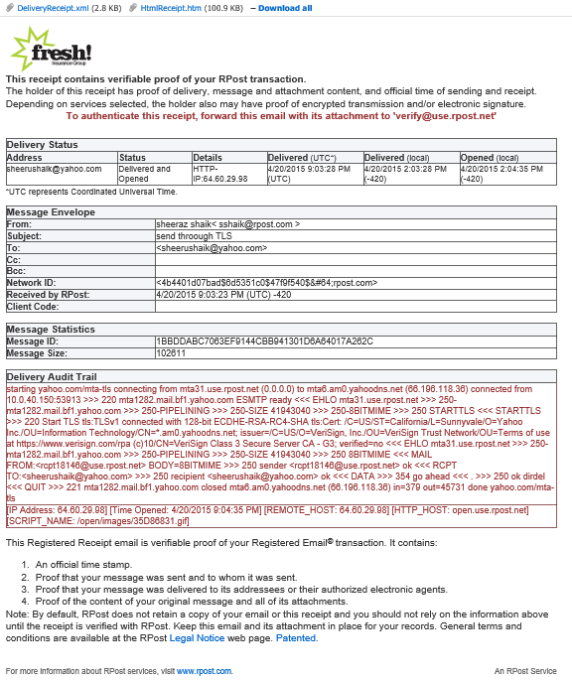

# Open Receipt

* Open Receipt will get generated, when recipient opens the email/message after 2 hours of receiving the mail.
* Open Receipt should not get generated, if recipient opens the email after 30 days. I.e. the time limit for Open receipt is more than 2 hours and less than 30 days.
* Open receipt should never get generated ,if the status in receipt is “Delivered and Open “ , which means recipient has opened the message within two hours of receiving the message.
* Open receipt should get generated only once for each message.
* Open Receipt to sender should include two attachments i.e. , Delivery Receipt.xml and HTMLreceipt.html
* Delivery Receipt:
* HTML Receipt :
* Open Receipt should also include all the details of message like subject, sender, recipient, time sent, time opened, message id, network id etc.
* Open Receipt should be generated for solo recipients only. Multiple recipients cannot be included in a single Open receipt.
* Open receipt can be authenticated by sending it to [verify@use.rpost.net](mailto:verify@use.rpost.net) ( For staging )

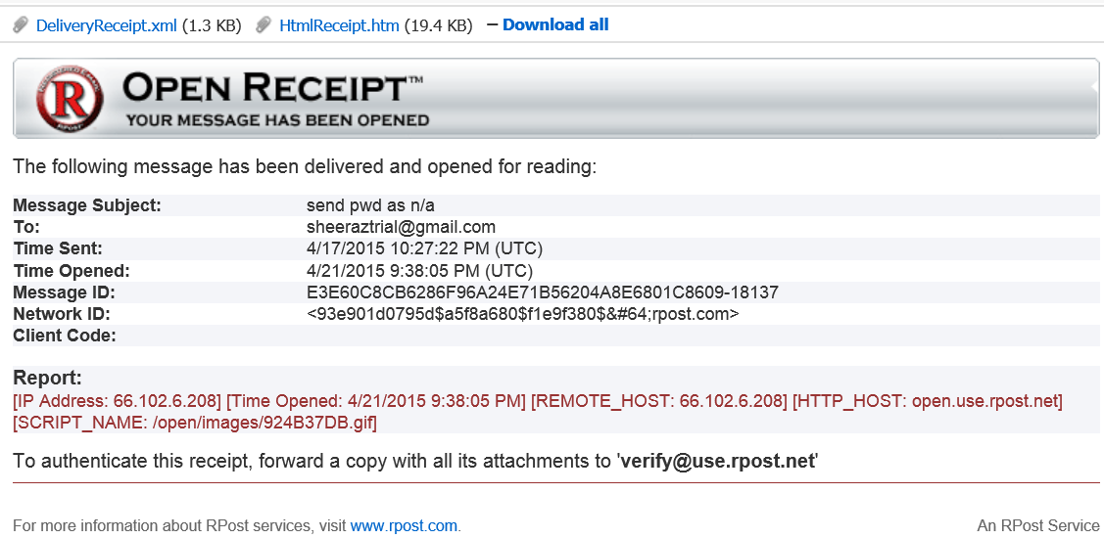

# Receipt Authentication

* Registered Receipts and Open Receipts can be authenticated by sending it to “[verify@rpost.use.net](mailto:verify@rpost.use.net)” or “[verify@usw.rpost.net](mailto:verify@usw.rpost.net)”
* Once the Registered Receipt email is verified, RPost returns an authenticated receipt with the transaction audit trail, forensics, reconstructed original email/attachments, and times sent and received.
* After the receipt is verified , the original email sent and Internet records are re generated , from the cryptographically stored , ‘HTML receipt” file attached to the registered receipt email
* When the receipt is tampered or modified , RPost sends out a failed authentication email to sender

**Receipt Authentication email is as shown below:**

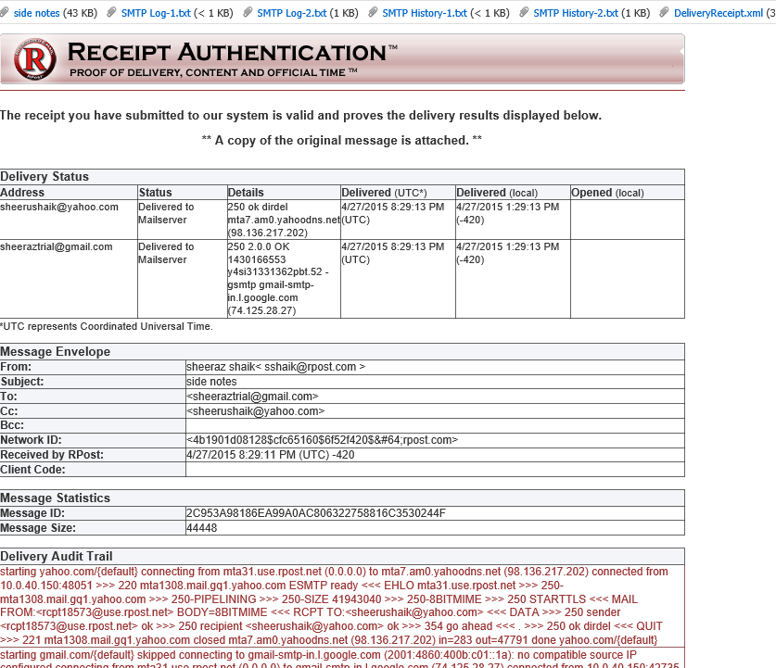

# Final E-Sign off Document

* Final E-Sign off document gets generated , once all the recipients signs the document/contract
* Final e sign off document contains a digital signature for integrity , the signers types data , The signers signature , time/date stamp on all pages and a detailed signing certificate page.
* Final e-Sign off document is electronically signed with the senders email address, time/stamp and optionally with the senders company logo as well.
* Final e sign off document can also be verified/authenticated by forwarding it to [verify@use.rpost.net](mailto:verify@use.rpost.net) or [verify@usw.rpost.net](mailto:verify@usw.rpost.net)
* Final e sign off document contains the original document , all the extra text added by the recipients and also Signature certificate at the end of the document
* Signature certificate at the end of the e sign off document gives the information about the original recipient email address, signature, name of the recipient and time stamp of the signature on the document.
* Final E-sing off document should not get generated , when any of the recipient declines the contract
* When the sender retrieves the partially signed contract, then final e contract should get generated with the only available signatures on the contract.

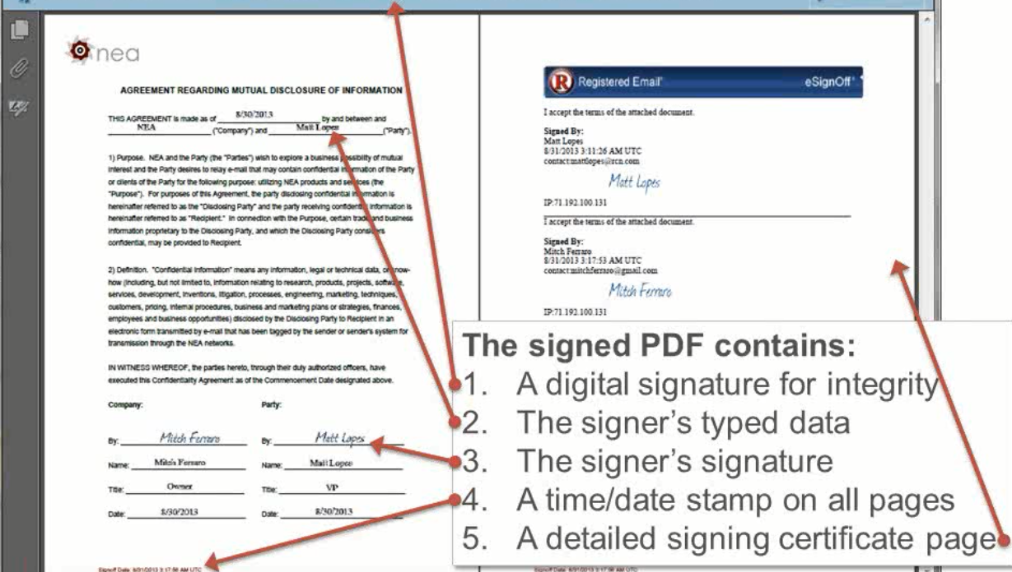

# X-Headers List

|  |  |  |  |  |
| --- | --- | --- | --- | --- |
| **Live System (Legacy format)** | **New format (Beta system only)** | **Type** | **Value** |  |
| **General** |  |  |  |  |
| XRPost-Type |  | Integer | 1 | With Registered E-mail banner |
|  |  |  | 2 | Without banner |
|  |  |  | 3 | Marked with "For Official Use Only" |
| XRPost-App |  | String | <sending_app_name> | Name of the sender application |
| XRPost-NoAck | X-RPost-NoAck | Integer | 1 | Suppress acknowledgements |
| XRPost-Receipt | X-RPost-ReceiptCopy | String | <address_list> | Addresses for addition copy of Registered Receipt |
| XRpost-ClientCode | X-RPost-ClientCode | String | <user_client_code> | User specified string to be included in Receipt |
| XRPost-Brand |  | String | <brand_name> | Service brand used |
| XRPost-Language | X-RPost-Language | String | <locale_culture_code> | Locale language culture code |
| XRPost-Version |  |  |  |  |
| XRPost-Account |  |  |  |  |
| XRPost-Distrib | X-RPost-Distrib | String | <distributor_name> | Distributor of RPost App / Outlook Add-in |
| XRPost-xpswd |  | String | <password> | RPost generated password to authenticate digital seals |
| XRPost-Sidenote-Text | X-RPost-Sidenote-Text | String | <sidenote_text> | User generated text for RPost SideNote (up to 512 characters |
| XRPost-Sidenote-Bcc | X-RPost-Sidenote-Bcc | String | <address_list> | Append SideNote™ to BCC recipients of this message |
| XRPost-Sidenote-Cc | X-RPost-Sidenote-Cc | String | <address_list> | Append SideNote™ to CC recipients of this message |
| XRPostSealSig | X-RPost-Seal |  |  |  |
| XRPost-SealHash | X-RPost-Seal-Hash |  |  |  |
| **Attachment Options** |  |  |  |  |
| XRPost-CleanMetadata | X-RPost-Convert-CleanMetadata | Integer | 1 | Clean Meta-Data from attached MS Office files |
| XRPost-Convert2Pdf | X-RPost-Convert-Pdf | Integer | 1 |  |
| XRPost-Pdf-Doc | X-RPost-Convert-Pdf-Doc | Integer | 1 | Convert attached DOC files to PDF |
| XRPost-Pdf-Ppt | X-RPost-Convert-Pdf-Ppt | Integer | 1 | Convert attached PPT files to PPT |
| XRPost-Pdf-Xls | X-RPost-Convert-Pdf-Xls | Integer | 1 | Convert attached XLS files to PDF |
| XRPost-PdfPassword | X-RPost-Convert-Pdf-Password | String | <password> | (Optional) User generated Password for generated PDFs |
| XRPost-ZipFiles | X-RPost-Convert-Zip | Integer | 1 | Zip attached files in transit |
| **Electronic Signatures** |  |  |  |  |
| XRPost-Signoff | X-RPost-Esign | Integer | 1 | Hand Sign |
|  |  |  | 2 | Email Sign |
| XRPost-SignoffExpiration | X-RPost-Esign-Expiration | Integer |  |  |
| XRPost-SignoffSequential | X-RPost-Esign-Sequential | Integer | 1 | Sign in serial sequential order |
| XRPost-SignoffText | X-RPost-Esign-Text | String |  |  |
| XRPost-ReplyReg | X-RPost-ReplyRegistered | Integer | 1 |  |
| XRPost-ReplyRegistered | X-RPost-ReplyRegistered | Integer | 1 | Replies to this message will be Registered E-Mail® messages. |
| **Encryption** |  |  |  | Replies to this message will be Registered E-Mail® messages. |
| XRPost-SecuRmail | X-RPost-SecuRmail | Integer | 1 | Message to be sent as RPost SecuRMail. Must be locally encrypted or sent with TLS/SSL |
| XRPost-SecuRmailPassword | X-RPost-SecuRmail-AutoPassword | Integer | <password> | User generated password for Secu(R )mail™ PDF |
| XRPost-AutoPassSecure | X-RPost-SecuRmail-Password | String | 1 | Use system generate password for SecuRmail |
| X-Rpost - RetrievePassword |  |  |  |  |

# Subject Line Commands

The implementation was based on that spec and does the following (tags are not case sensitive):

2PDF - Convert to PDF (selecting all options: word, ppt, xls), equivalent to setting XRpost-headers ConvertToPdf, ConvertDocToPdf, ConvertPptToPdf, ConvertXlsToPdf

2PDF(passw) - As above + encrypt PDF option selected

(RPMD) - Clean hidden metadata from office files option, equivalent to setting XRpost-ClearMetadata

RPX - Hand esign

RPXS - Sequential hand esign

RPY - Email esign

RPYS - Sequential email esign

(ZIP) - Zip attached files

(R) - Registered

(R+) - Registered w/reply registered

RPSX(passw) - Encrypt and send password notification based on user’s db settings

RPSY(passw) - Encrypt and always send password notification regardless of user’s db settings (except for EnterpriseUser)

RPSZ(passw) - Encrypt and never send password notification regardless of user’s db settings (except for EnterpriseUser)

# Control History

|  |  |  |  |
| --- | --- | --- | --- |
| **Date** | **Version** | **Updates** | **Updated By** |
| 6/15/2015 | 1.0 | Draft version | Sheeraz Shaik |
| 6/18/2015 | 1.1 | Incorporated headers and subject line commands | Sheeraz Shaik |